Academic Year: 2025-26 | Year: Second Year | Semester: II
PRN No.: 1012411011 | Name: Riddhee Kulkarni
Subject: Python Programming
Assignment No.: 21
Date: 16/03/2026

Lab Assignment: 21
Aim:
To write a Python program to check whether a given character is present in a string and print the index at which it occurs.

Objective:
- To understand string searching in Python.
- To check whether a character exists in a string using the in operator.
- To find the position of the character using the index() method.

Theory:
A string is a sequence of characters in Python. Python provides several built-in methods to manipulate and search strings.
- The in operator is used to check whether a specific character or substring exists in a string. It returns True if present, otherwise False.
- The index() method returns the first occurrence of the specified character in the string.
- If the character is not present, index() normally raises an error, but using it after checking with in prevents the error.
Example:
If the string is "hello" and the character is "l", the output will be 2, because indexing in Python starts from 0.

Algorithm:
- Start the program.
- Accept a string from the user.
- Accept a character to search in the string.
- Check if the character exists in the string using in.
- If present, use index() to find its position.
- Print the index of the character.
- If not present, print that the character is not found.
- Stop the program.

Pseudo Code:
START

INPUT string
INPUT character

IF character in string
index = string.index(character)
PRINT index
ELSE
PRINT "Character not present"

END

Code:
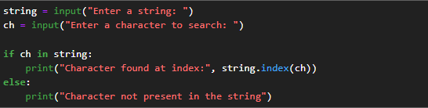

Output:
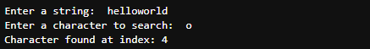

Conclusion:
Thus, the Python program was successfully implemented to check whether a character exists in a string and to display the index of its first occurrence if it is present.

